Using Visual C++ with Horstmann's Object Libraries

Compiling a simple program
- Start Visual Studio
- Make sure the following windows are visible, and open them from the "View" menu if not:
- Solution Explorer
- Start Page
Close the "Properties" window if it is open, as it will only confuse things.
- Select "Create Project" from the Start Page Tab, or File -> New -> Project from the menu
- In the resulting dialog, select Visual C++, Win32, and select "Win32 Console Application". Then type in the name for your project in place of the <Enter_Name> and make sure the location is where you want: (such as d:\Visual Studio Projects\ for the local persistent hard drive, or on your Flash drive if you prefer to work there). Click OK
- 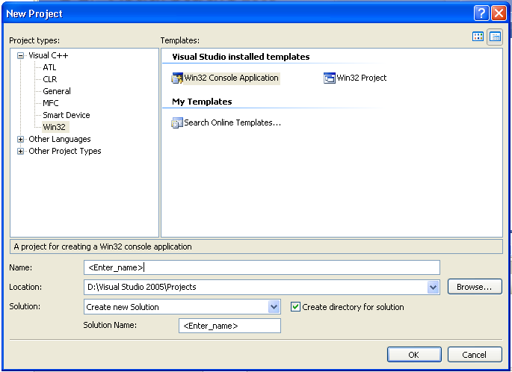
In the "wizard" dialog, click on the Application Settings tab, or click Next. Check the Empty Project check box, which is NOT the default.
Then click Finish.

- In the Solution Explorer Window, right click on "Source Files" folder. Select Add New Item... from the menu.
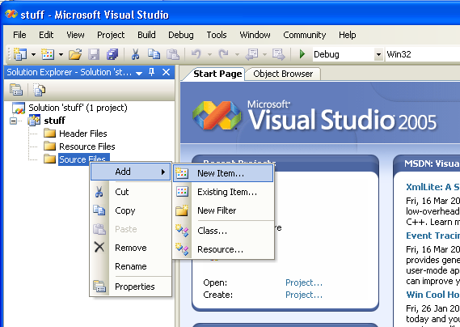
- In the resulting dialog, choose Visual C++ and Code, click on C++ file, then enter a name in the textbox at the bottom such as "MyFirstProgram" in place of the <Enter_Name>. Finally, click on Add.
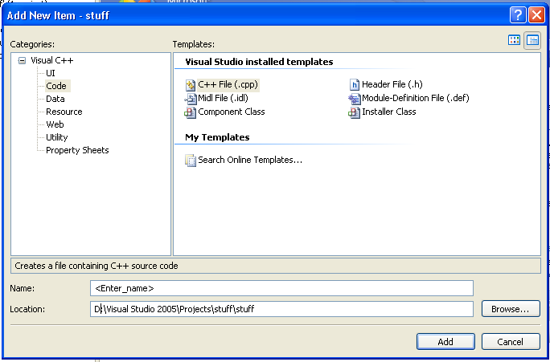
(Note that you can ADD an existing CPP file to your project instead of a new file, but we do not recommend it -- because this existing source file likely is not in the project folder, but still in its original location, and that can confuse you. Also the existing file may be a shared source which we do not want to modify).
- Now Visual Studio shows you the empty .CPP file. You may either start typing in your C++ code in that empty file, or you can open an existing .CPP file from the "File Open File" menu at the top left, and then copy its contents into your new CPP file. To do this copy, use ctl-A, ctl-C and ctl-V from the keyboard, or with the mouse successively right click, and choose "Select All, Copy" from the existing file and right click on the empty new file, choosing "Paste".
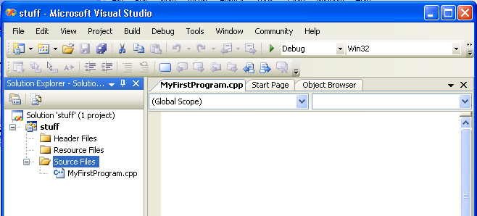
- When you have finished typing in or pasting your C++ code, you are ready to compile it. Type ctl-F5 (Start without Debugging) as a shortcut. This will compile and run your program, if it is error free. Alternatively, if you prefer no shortcuts, you can click the "Debug" menu item and choose "Start without Debugging". Later we will use "Start Debugging" (F5), but for now, we'll avoid it.
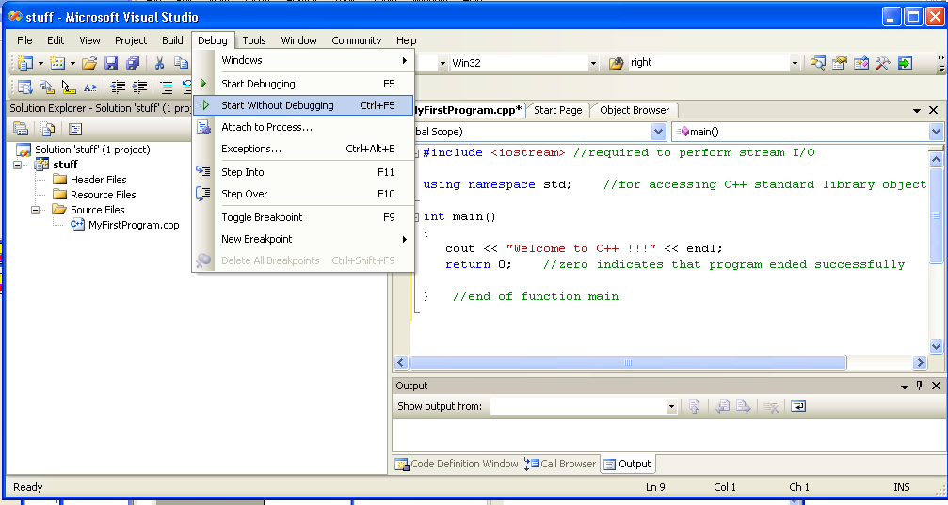
- If your program has no syntax errors, and compiles properly, you will see a DOS-like black box screen with your output. You may hit any key to continue, at which time the black box will disappear and return you to Visual Studio.
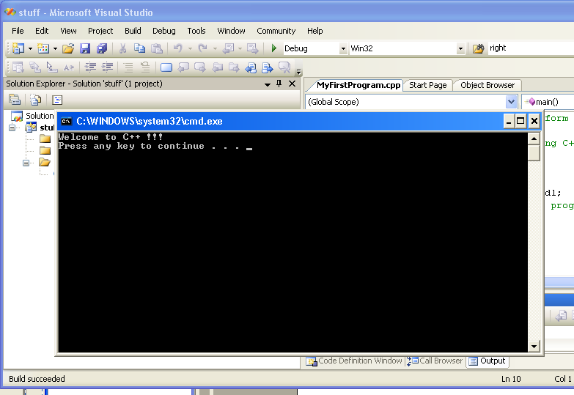
- If however, your program has syntax errors, look in the Output window at the bottom of Visual Studio to point you to the errors. You may double-click on the error message to have Visual Studio take your cursor to the erroneous line in the program, and modify the code, then Ctl-F5 again. If prompted with "There were build errors. Would you like to continue and Run the Previous Version ?", PLEASE click NO, then fix the error(s). If you instead click YES, you will run an old version of your program which does not match your current code.
